MICROPROCESSOR AND INTERFACING EXPERIMETN 3

M.S.SANJAY

15BCE0517

1.Factorial

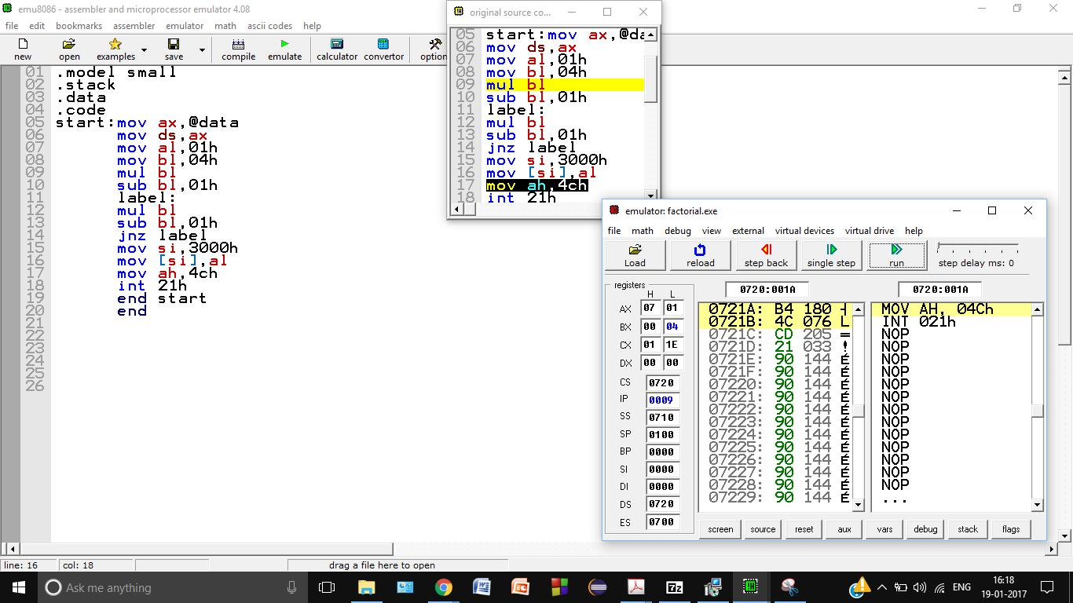

After Completion

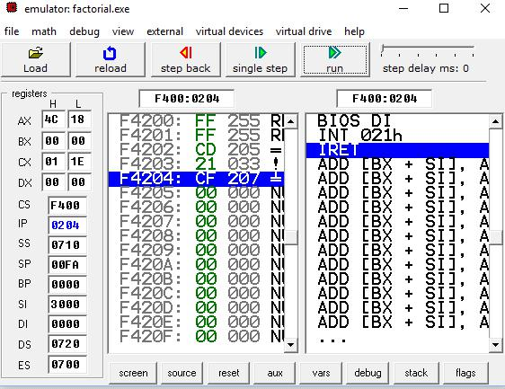

18 is in hexa decimal= 24 decimal=4!

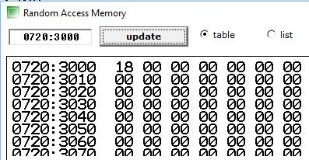

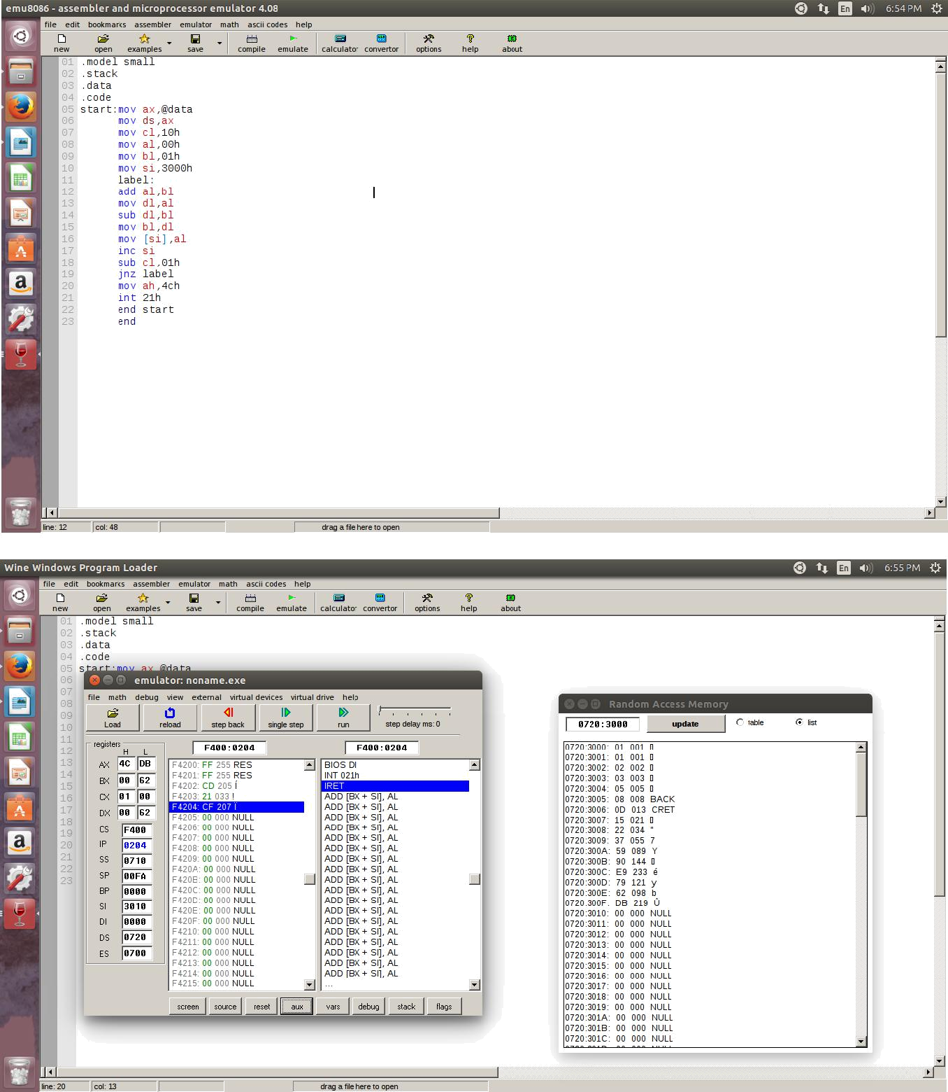2.Fibonacci

3). NPR- 5P2

Ans-in decimal 20

In hexa decimal 14

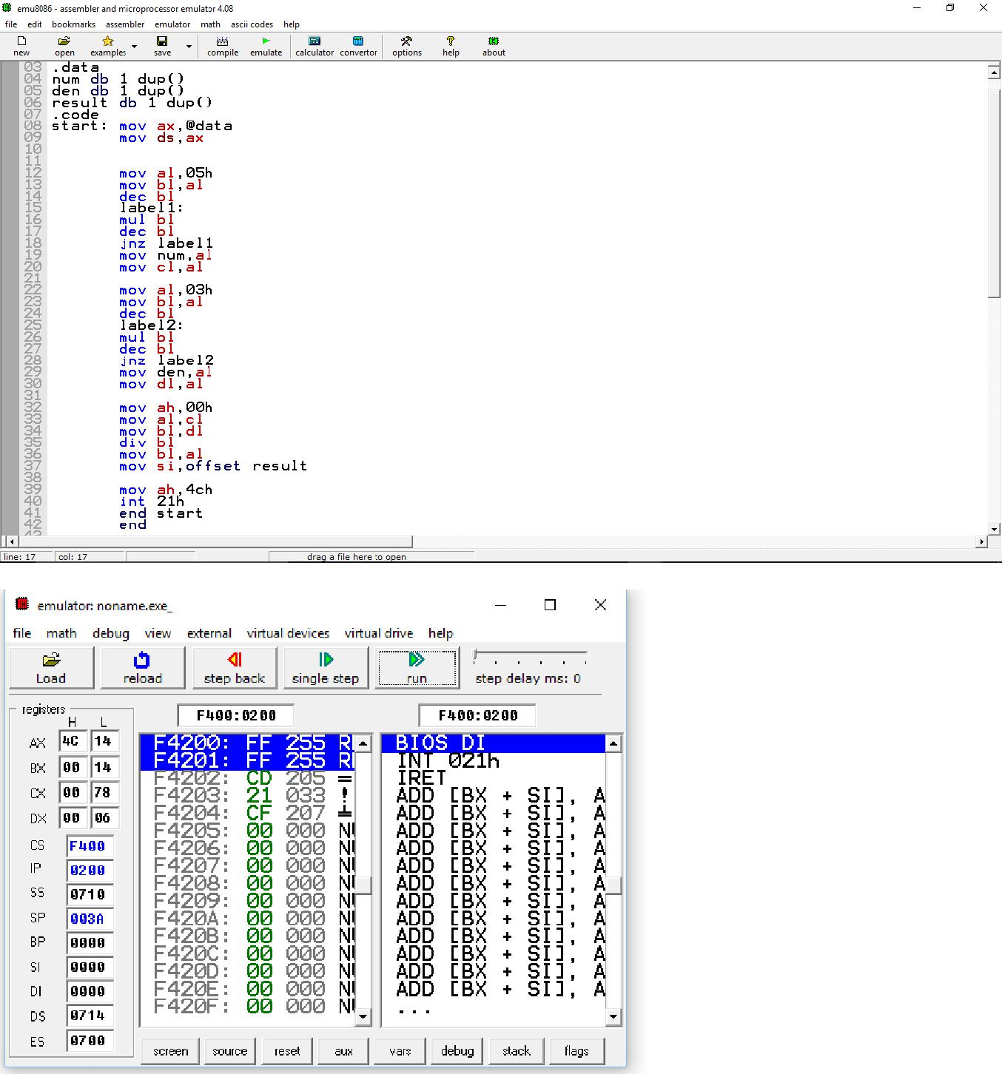

NCR-5C2

Ans-In decimal 10

In hexadecimal A